Ss. Peter and Paul
Catholic Primary School

Curriculum Policy

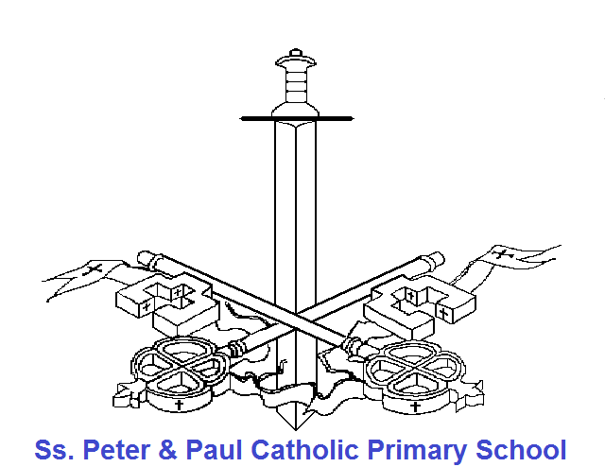

This policy is to be read in conjunction with individual subject policies which are updated and kept in the Curriculum Statements of Practice file in the staffroom
Ss. Peter and Paul Catholic Primary School

At Ss. Peter and Paul Catholic Primary School the individual policies for each subject should be read in conjunction with this policy which meet the statutory requirements for each subject. All children have a right to a broad, balanced and relevant education which provides continuity and progression and takes individual differences into account. Work in our school is planned to meet the requirements of the national Curriculum.

Ss. Peter and Paul Catholic Primary School aims to
- Cater for the needs of individual children of both sexes from all ethnic and social groups, including the most able and those who are experiencing learning difficulties.
- Facilitate children's acquisition of knowledge, skills and qualities which will help them to develop intellectually, emotionally, socially, physically, morally and aesthetically, so that they may become independent, responsible, useful, thinking, confident and considerate members of the community.
- Create and maintain an exciting and stimulating learning environment.
- Ensure that each child's education has continuity and progression.
- Ensure that there is a match between the child and the tasks s/he is asked to perform.
- Provide a broad and balanced curriculum.
- Recognise the crucial role which parents play in their children's education and make every effort to encourage parental involvement in the educational process.
- Treat children in a dignified way.
We aim that all children should
- Learn: to be adaptable; how to solve problems in a variety of situations; how to work independently and as members of a team.
- Develop the ability to make reasoned judgements and choices, based on interpretation and evaluation of relevant information from a variety of sources.
- Be happy, cheerful and well balanced.
- Be enthusiastic and eager to put their best into all activities.
- Begin acquiring a set of moral values, such as honesty, sincerity, personal responsibility, on which to base their own behavior.
- Be expected to behave in a dignified and acceptable way and learn to become responsible for their actions.
- Care for and take pride in their school.
- Develop tolerance, respect and appreciation of the feelings and capabilities of others in an unbiased way.
- Develop non-sexist and non-racist attitudes.
- Know how to think and solve problems mathematically in a variety of situations using concepts of number, algebra, measurement, shape and space, and handling data.
- Be able to listen and read for a variety of purposes and be able to convey their meaning accurately and appropriately through speech and writing for a variety of purposes.
- Develop an enquiring mind and scientific approach to problems.
- Have an opportunity to solve problems using technological skills.
- Be capable of communicating their knowledge and feelings through various art forms including art/craft, music, drama and be acquiring appropriate techniques which will enable them to develop their inventiveness and creativity.
- Know about geographical, historical and social aspects of the local environment and national heritage and be aware of other times and places and recognise links among family, local, national and international events .
- Have some knowledge of the beliefs of the major world religions.
- Develop agility, physical co-ordination and confidence in and through movement.
- Know how to apply the basic principles of health, hygiene and safety.

Learning
Through Learning we hope to help children:
- Learn the essential knowledge, skills and understanding of a broad range of curriculum subjects.
- Engage with their learning so that they remain committed to learning throughout their school careers and their lives.
- Develop the personal qualities they need to be good citizens and to respond to the changing contexts of their future lives.
- Develop a sense of their own nationality and culture at the same time as developing a profound respect for the nationalities and cultures of others.

Teaching
The purpose of teaching is to help children learn. But teachers need help and support too. Teaching should be as enjoyable and rewarding for teachers as much as learning should be enjoyable and rewarding for children.
Our curriculum is designed to allow teachers to spend more time developing creative, personalised learning for their children.
This policy/document was reviewed by:-  Signed………………………………………………………………………………………………  Position…………………………………………………………………………………………….  Signed.…………………………………………………………………………………………….  Position.………………………………………………………………………………………….. |  | Date:  Date:
The next revision date is: | ………………………………………….

