Ss. PETER AND PAUL
CATHOLIC PRIMARY SCHOOL
RELIGIOUS EDUCATION POLICY

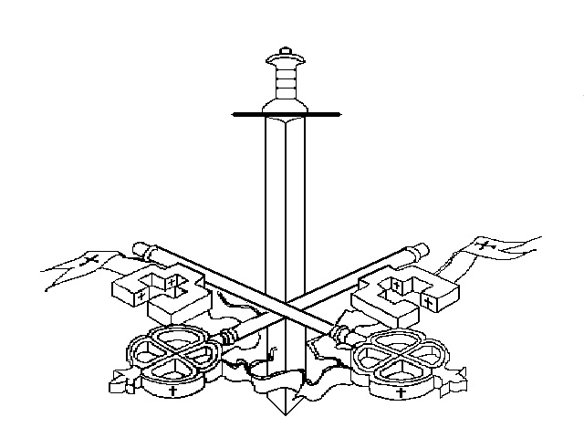

To grow in knowledge and love,
and walk in the footsteps of Jesus.

Mission Statement

To grow in knowledge and love,
and walk in the footsteps of Jesus.

Introduction
Ss. Peter and Paul Catholic Primary School believe that Christian worship in a Catholic school is concerned with giving glory, honour, praise and thanks to God. It is our loving response, in word and action, to God’s invitation to enter into relationship, made possible through the work of Jesus Christ and the witness of the Holy Spirit.
We are fully committed to providing opportunities for all children to know, love and serve God, in such a way that will enrich their own lives and help them to understand their Catholic faith traditions, in an ever changing world and within the multicultural society they live in.
Together, following in the footsteps of Jesus, we endeavour to foster responsible, happy, caring and kind people who will be effective stewards and make a positive difference in our world.

Aims and Objectives
- To foster a love of God through knowledge and understanding of the Catholic Faith from scripture and doctrine.
- To encourage the development of a personal relationship with God.
- To help our children to be aware of and respect other faiths.
- To encourage children to study, investigate and reflect.
- To develop thinking and listening skills.
- To develop respect for truth and for the views of others.

Entitlement
We follow the Religious Education programme ‘The Way, The Truth and The Life’, as adopted by the Shrewsbury Diocese.
Two topics per year group are studied each term.
It is the policy of the school to give at least 10% teaching time to RE. We view the total curriculum in our school as based on the values of the Gospel and we see all education as revealing the mystery of God. During Holy Week, Advent, Lent and other times, there will be an increased entitlement.

Teaching and Learning in R.E.
A range of teaching strategies and learning methodologies will be employed depending on the needs and abilities of the children and the nature of the activities being undertaken.
Work will be differentiated in terms of activity, teacher support or outcome according to the needs and abilities of the children.
Approaches will include whole class and year group teaching as well as group activities.
Children will have opportunities to work individually as well as co-operatively and collaboratively, developing their own knowledge and expertise as well as sharing their experiences with others.
All work will involve thought provoking reflection and discussion, encouraging the children to develop their moral and spiritual consciences.
Our parents are kept well informed about RE through our curriculum letters which are sent out each half term, detailing the new topics to be covered.
All staff will have received by the end of 2016, Lat Blaylock training on creative curriculum in RE. Colleagues work together to plan, assess and moderate work every half term and also attend INSET for prayer trails and staff collective worship.

Prayer
Prayer is a fundamental part of our school life including formal prayers and children’s own informal prayers.
Additional prayers in F2, KS1 & 2 include prayers at the beginning and end of the school day and prayers before meals.
Informal prayer has a very important place in the spiritual life of our children and includes the everyday language of praising, thanking, asking and saying sorry.
Informal prayer encourages reflection by all pupils on their everyday life.
Parents, carers, governors and helpers are invited to class assemblies, liturgies and Advent and Lent assemblies and prayer trails. All families are welcome to attend family Masses.
School have a set of school prayers which are used alongside traditional prayers including the Angelus. Father Phil and Father Michael come in to work with classes, lead Sacramental Preparation, for class Mass and reconciliation services. Father Michael has a rolling programme to work with all classes on his weekly whole-day visits.

Liturgical worship
Through worship we aim to join the work of home and Parish in developing the Spirituality of the children and to develop the concept of worship as an integral part of School life.
We also aim to develop an understanding of different forms of worship and to reflect the multicultural nature of our children in various acts of worship.

Ways in which we provide opportunity for different forms of worship:
- Careful preparation of school masses.
- Values and liturgical feast Assemblies on Friday, Superstar and celebration assemblies on Monday, Class assemblies on Wednesday mornings and Other Faith Assemblies. School also arrange a number of visiting speakers to come in throughout the year such as NSPCC, CAFOD, Missio, Claire House and charitable causes children want to support.
- Special liturgical services to celebrate feasts of the Church's year.
- Classroom Worship supported by focal areas where the children can reflect and pray. These are set up in each classroom to reflect changing topics. Room is left for the children to add to the display and Collective Worship boxes.
- School have a number of prayer stations including the school prayer garden, the prayer room and focus prayer stations where children can spend a moment to reflect and pray.
- Advent and Lenten prayer trails allow children to draw nearer to God.
Please refer to Collective Worship Policy for more detail.

Sacramental Preparation
Sacramental preparation forms an integral part of school life. The children are formally prepared for the Sacraments of Reconciliation and Holy Eucharist when they reach Year 3. This special time is considered a year of special celebration by all in school.
Y3 children taking part in Sacramental Preparation take a special part in our regular Parish family Masses.
At school, we work in close partnership with our families and the Parish to support the child with his/her sacramental preparation. Activity books are sent between home and school to help parents and guardians take a joint active part in sacramental preparation. School organise a retreat day just before the celebration of First Holy Communion to reflect and celebrate and prepare for this special time.
Sacramental preparation is conducted in addition to the RE timetable after school. This work greatly supports and enhances the WTL RE curriculum. Parents are invited to attend at certain points of the programme for opportunities for joint prayer, reflection and celebration.

Assessment
We recognise that assessment, recording and reporting are a natural part of teaching and integral to the learning process but it is impossible to assess the level of a child’s personal faith and it should not be attempted. However, we are able to assess the child’s knowledge, skills, concepts and attitudes which have been taught in RE.
The assessment of standards is carried out using the criteria set out in the Levels of Attainment booklet agreed by the Bishops’ Conference.
Teachers continually make assessments using strategies such as:
- Looking at children’s recorded work and marking.
- Teacher observations of children during role play, carpet time etc.
- Speaking and listening contributions during lessons.

In F2, KS1 & KS2 class teachers assess all topics in class, however there will be one formal assessment of children’s work per term for the RE team to monitor and track. The formal assessment for each term will be levelled by the class teacher and moderated within bands.
A sample of levelled work each term, covering a range of abilities will also be given to the subject leader to form part of the school portfolio.
The RE team and teachers will meet regularly to moderate work together.
At the end of each year, the children should be levelled in accordance with agreed level thresholds.
Religious Education is reported to parents/carers through parents’ evenings and in a written report at the end of each academic year.

Monitoring of teaching and learning
In order to monitor the teaching and learning of Religious Education, lesson observations are carried out by the Subject Leader, governors and members of the RE Team, Assistant Headteachers or the Headteacher.
Book scrutiny is also carried out by the Subject Leader, governors, members of the RE team, whole teaching staff and learning walks by the Head Teacher.
Planned discussions with pupils may also take place, if appropriate.
Resources
Resources for RE are kept in the classrooms and the RE resource area including the prayer room and are accessible to all staff. Resources (including artefacts, books etc.) are constantly reviewed and updated and are multi-cultural in nature. Artefacts, statues, candles etc. are also placed strategically around the school.
Each class is resourced with Bibles suitable to each age group, a Collective Worship resource box, as well as personal resources. Retreat/artefact boxes are shared with St Mary’s Catholic College. All Wallasey cluster schools design, make and share resources together.

Other Faiths
We aim to develop the children’s knowledge and understanding of other faiths and a willingness to empathise with people who hold beliefs that are different from our own. We help the children to learn from religions as well as about religions.
There are two ‘Other Faith’ weeks built into the school calendar as an addition to the RE provided. At Ss. Peter and Paul Catholic Primary School, it has been decided that faiths will be studied on a rolling programme including Islam, Buddhism, Sikhism and Hinduism. Judaism repeats every year as well as input from the WTL scheme. Other faiths are on a rolling programme.
Should a pupil of another world faith, not recently celebrated, be admitted to our school, then this faith would also be included, if appropriate.

Management of the subject
Mrs. Bernie Brown is Subject Leader, and has responsibility for leading, managing and supporting the delivery of and training in Religious Education. She is supported with an RE team on the staff. This consists of Miss Devonshire, Mrs. Gallon, Miss Rickett, Mrs. Wellens and Mr. Meadows.

Review
The Head Teacher and staff will review this policy in the Autumn Term 2016.
Any suggested amendments will be presented to Governors for discussion and approval.

RE Team
Updated January 2016

APPENDIX 1
The Role of the Co-ordinator for Religious Education
The Religious Education Co-ordinator will be responsible for:

- Working with senior leaders on monitoring teaching and learning, planning and standards through lesson observations and work scrutinies according to school practice.

- Organising and maintaining the school portfolio of pupils’ work.

- Organising in-house moderation of standards meetings.

- Self- evaluation to identify strengths and areas for development.

- Ensuring the curriculum offered is appropriate, suitable and relevant to pupils’ needs and interests.

- Attending appropriate training and keeping up to date with current thinking, policy and developments and feeding back to staff.

- Organising and leading in-house staff training and development.

- Identifying training needs of staff to ensure their suitability to teach effective Religious Education.

- Supporting and advising colleagues in the delivery of Religious Education.

- Liaising with the Headteacher, Governors, parents, the Office for Education & Schools on matters relating to Religious Education.

- Auditing, managing and developing resources within a given budget.

