Ss. PETER AND PAUL CATHOLIC PRIMARY SCHOOL SMSC POLICY
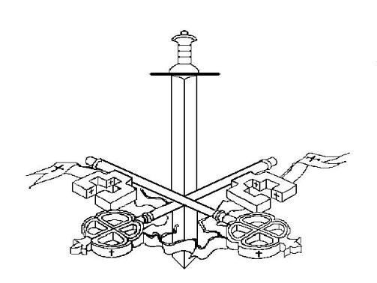

To grow in knowledge and love, and walk in the footsteps of Jesus.

Policy for SMSC

This policy has been developed within

the spirit and context of our Mission Statement.

Mission Statement

To grow in knowledge and love,
and walk in the footsteps of Jesus.

Rationale

The distinctive nature and religious character of our school is not something that can be restricted to the R.E. lesson but must present itself in all aspects of our school life especially in the way we aim to assist the spiritual, moral, social and cultural development of our pupils.

At Ss. Peter and Paul’s we believe that education is a means of proclaiming and revealing the life and teachings of Jesus Christ to our children so that they may develop fully as human beings and discover purpose and meaning in their lives, now and in the future.

Spirituality at Ss. Peter and Paul’s school is concerned with raising and developing an awareness in each person of a sense of God and the way God acts in our world and in our lives.

Social development at Ss. Peter and Paul’s is concerned with leading children to understand that we are made not only for ourselves but to live with, in and through community. Only in community are we able to live out Gospel values. We believe that good relationships which are based on mutual respect and love are the key to a harmonious environment where all can work together towards the common good. We further believe that what is learned in our school community will enable our children to understand the wider community and their Christian role in society.

Cultural development in Ss. Peter and Paul’s is concerned with the cultures and traditions represented in our school, its immediate environment, our country and the world. As Catholics, we value the wide cultural diversity in the worldwide expression of our beliefs within our own faith worldwide. We believe that it is our duty to lead our children, through the development of respect and understanding, to learn to live with a wider variety of people from different national, cultural, racial and religious backgrounds


2
Aims for Spiritual, Moral, Social and Cultural Development

At Ss. Peter and Paul’s we aim to:

- provide an atmosphere of peace, welcome, friendliness, co-operation and tolerance where every person is valued as a unique and special child of God;

- foster caring relationships between all those who are members of our school community;

- provide a high quality of pastoral care;

- provide the opportunity for every child to achieve their true potential through the experiences which they receive and the knowledge they acquire;

- enable children to develop an understanding and respect for different beliefs and cultures.

To achieve these aims we will provide in our implicit and explicit curriculum opportunities for children to:

- learn that we, as Catholics, believe that life is a spiritual journey towards God in which we develop our relationship with Him through prayer and worship;

- explore and question their own experiences and interpretations of them in a secure and loving environment;

- respond to and express their reactions to their own inner experience and that of others in a variety of forms;

- have time for quiet reflection, individually or as a member of a group;

- develop a sense of awe, wonder and mystery in the natural world and feel a sense of God in the order and beauty of His Creation;

3

- develop an appreciation that although we as Catholics believe that we are made in the image and likeness of God, different traditions may celebrate the worth of being human in different ways.

- explore and express their innermost thoughts, creativity and imagination and show an awareness and valuing of the feelings and beliefs of others;

- explore how people have expressed their feelings through literature, poetry, art, design, music and dance and learn from this how to express their feelings through their own work;

- come into contact with the beliefs and practices of others through story and festival and by meeting visitors from other faiths;

- develop the beliefs and values of the home and family through the Gospel values and attitudes which we as a school community uphold and foster;

- establish positive school relationships based on tolerance, acceptance, appreciation and respect;

• understand that injustice, aggression or rejection can hurt others;

- think about and reflect on their own lives and explore the lives of people who exemplify qualities which are universally valued.

Implementation and Organisation

In order to promote the spiritual, moral, social and cultural development of our children we will;

- ensure that the school and classroom environment is stimulating and well ordered to promote positive learning and encourage personal development and responsibility;

- using the teachings and doctrine of the Catholic Faith to promote positive relationships with and respect for all individuals and groups;

- through the implementation of the R.E. Policy, lead children to an awareness of spiritual values and an understanding that, regardless of

4

colour, gender, status or religion, God is truly concerned about and loves every single person;

- promote positive values, qualities and attitudes and discourage negative ones through the implementation of our school Behaviour Policy;

- foster social skills through teamwork and co-operative projects and encourage development of social responsibility by support for charitable ventures.

