Ss. Peter & Paul
Catholic Primary School
+


Managing Medicines in School



This policy has been reviewed and updated in line with the DfE Statutory Guidance,
Sept 2014 on Supporting Pupils in School with Medical Conditions.
It will be reviewed annually

Purpose
‘To ensure that all children with medical conditions, in terms of both physical
and mental health, are properly supported in school so that they can play a
full and active role in school life (including school trips and physical
education), remain healthy and achieve their academic potential.’
DfE Statutory Guidance, Sept 2014

Managing Medicines in School Policy

1. Introduction

At Ss. Peter and Paul, we are committed to reducing the barriers to sharing in school life and learning for all our pupils. This policy outlines the operational management and safety implications of medicines brought into Ss. PP and sets out steps, which the school will take to ensure full access to learning for all our children who have medical needs and are able to attend school.

Parents should keep children at home when they are acutely unwell. Medicines should only be taken to school where it would be detrimental to a child’s health if it were not administered during the school day.

Prescription medicines will be given in line with this Policy. No child should be given prescription or non-prescription medicines without their parent’s written consent.

Aspirin or ibuprofen will NOT be administered unless prescribed by a doctor. Parents are welcome to come in and give their child medicine if they wish.

1.1 Linked Policies

This policy should be read in conjunction with the following policies:

- Health and Safety

- Aims

The medicine in school policy is designed to:

- Ensure the safety of children in the school.
- Provide a framework that staff MUST follow to allow medicines to be brought into school for children.
- Set guidelines for staff medications.

- Legal Framework
Disability Discrimination Act 1995: (as amended by the SEN and Disability Act 2001) makes it a requirement for schools not to unjustifiably discriminate against children with disabilities, including those with medical needs.

Health and Safety at Work Act 1974 and Management of Health and Safety at Work Regulations 1999: School managers have a responsibility to ensure that safety measures are in place to cover the needs of all staff, visitors and children in the school. This may mean conducting risk assessments and making special provision for children with particular health needs.

Control of Substances Hazardous to Health Regulations 2002: COSHH covers the use and storage of hazardous substances. Some medicines fall into this category.

Medicines Act 1968: This covers all aspects of the supply and administration of medicines. It allows any adult to administer a medicine to a third party as long as they have consent and administration is in accordance with the prescriber’s instruction. This includes the administration of some forms of injection (with appropriate training).

Misuse of Drugs Act 1971: This act and its associated regulations cover the supply, administration and storage of controlled drugs. At times schools may have a child who has been prescribed a controlled drug.

3.1 Further information

The DFES and Department of Health have jointly produced Supporting pupils at school with medical conditions, which can be found on the DfE website.

It should be noted that there is no legal duty that requires school staff to administer medicines but at Ss. Peter and Paul Primary School. We are willing to undertake this task to enable regular attendance, under the conditions set out below.

4. Policy and procedures

This policy covers the following areas:

- Procedures for managing prescription medicines that need to be taken during the school day.
- Procedures for managing prescription medicines on trips and outings.
- Roles and responsibilities of staff managing and supervising the administration of medication.
- Responsibilities of parents in respect of their child’s medical needs.
- The need for prior written agreement from parents before medicines can be administered.
- Assisting children with long term and complex medical needs.

- Staff training.
- Record keeping.
- Safe storage.
- Access to emergency procedures.

4.1 Permission to administer medication

Before giving medication to any child, we must have written agreement from the parents. This agreement will include the child’s name, the name of the medication, the required dose and agreed time of administration. It should also be clear whether the medication is on-going or to be taken up until a particular date. Any possible side effects should be listed and/or the information leaflet that is normally supplied by the manufacturer made available.

Parents should bring the medicine into school and hand it to the school office staff, who will record that it has been received.

Children must not keep medicines anywhere in school. They must be taken to the Office at the start of the school day. Medicines must not be administered by the child.

We only accept medication that is in its original labelled container.

The person receiving the medicine will check that the label indicates the name of the child, that the dose parents have stipulated coincides with that detailed on the label and that the medicine is ‘in date’. Where the medicine is in tablet or capsule form, they should, if possible, check the number provided.

4.2 Storage

All medicine brought into Ss. Peter and Paul Primary School will be taken to the school office where parents complete the medical form. The medical form and medicine are then sent to the child’s class teacher to be stored securely in the classroom. Medicines requiring refrigeration will be placed in the fridge in the Staffroom. For some identified pupils, medication is held securely in the locker in the staffroom or in the secure medical cupboard outside the main office.

Medicines can be classed as substances hazardous to health and as such must be stored securely. It is also important to note that some need to be stored at particular temperatures or away from light. This information will be on the medicine label and in the manufacturer’s information leaflet. Most medicines should be kept in a locked cupboard. The key should be kept safely, but children should know where their medication is and who can access it.

If medicine needs to be kept cool, then it should be placed in a fridge where children cannot freely access it. Store medicines in a labelled airtight container to keep them separate from food products.

Some emergency medication such as adrenaline pens (for children who suffer from allergies) and asthma inhalers should not be locked away as children need quick access to these. Personal adrenaline pens are stored in class first aid boxes held in classrooms. Spare adrenaline pens are stored in the school office.

4.3 Administration

As a general guideline before administering medication to a child, the staff member should:
- Wash their hands.
- Ensure that a drink is available if appropriate (some tablets can irritate and damage the throat and oesophagus if administered without a drink).
- Check the label on the medication: name of child, dose, route of administration (e.g. by mouth, into ear/eye, rubbed on the skin), any special instructions and expiry date.

When a child is given medicine he/she will first be asked his/her name and this name checked against the name on the medicine – even if the member of staff knows the child well. The appropriate form, signed by the parent, must be checked for the time the medicine is required and the dosage.

If there is any doubt about the procedure staff should not administer, but seek advice from parents or health professionals.

The medicine record sheet (Appendix A) must be checked to ensure that another member of staff has not already administered the dose. Using the record sheet applies mainly to children having regular long-term medication such as ritalin. Where a child is receiving prescribed short-term medication, the Medical Tracker is used to record when a dose has been administered. That way parents are alerted via email. If the administration of prescription medicines requires technical or medical knowledge, then individual training will be provided to staff from a qualified health professional.

If a child refuses the medication, they must not be forced. Staff can try to encourage them or perhaps get someone else to try. Under no circumstances should you attempt to hide the medicine in food or drink, unless you have written permission from parents to do so.

It is normally considered poor practice to give medicines covertly, although in rare cases where the health professionals judge that it is in the child’s interests to do so, this is acceptable. Some children do find tablets difficult to swallow so may be given them, with their full knowledge, in, for example, a spoonful of jam. Even in these circumstances parents must give written instructions. As some medicines can react with certain foods, it is advisable that they have sought advice from their pharmacist.

Occasionally mistakes will happen. In most cases, whether it is a missed dose or a medicine given in error there will be no harm done. Parents should be contacted and the mistake explained to them. In the case of a missed dose, you may be able to give it at a later time. Where a dose has been given in error, it is important that the child is monitored for any reactions and medical advice sought if you are in any way concerned.

When a child is on a school trip, the child’s class teacher or other designated person will administer any medication required. Medicine will be administered in accordance with the written instructions given by the parent on the appropriate form.

4.4 Record Keeping

In some instances, the forms in the Appendix will be used for record keeping. In some circumstances, it may be necessary to adapt the forms to meet the individual needs of children. Medical Tracker is also used (please refer to section 4.3)

The medicine record sheet (Appendix A) must be checked to ensure that another member of staff has not already administered the dose. Using the record sheet applies mainly to children having regular long-term medication such as ritalin. Where a child is receiving prescribed short-term medication, the Medical Tracker is used to record when a dose has been administered. That way parents are alerted via email. If the administration of prescription medicines requires technical or medical knowledge, then individual training will be provided to staff from a qualified health professional.

The date, name and class of the child, the type and dose of the medicine and the time of administration of the medicine, will be recorded on the appropriate form or on Medical Tracker together with the initials of the administrator.

If on a school trip a record must be kept using the appropriate form. Ensure this form is included in the child’s record on return to school.

4.5 Disposal

Tablets and capsules are occasionally dropped on the floor or spat out. In these cases, place the tablet in a labelled envelope and return it to the parents. In no circumstances should it be flushed down the toilet or thrown in the bin.

When a child leaves the school, ceases to need medication or if a medicine has passed its expiry date, return any that is unused to the parents. If this is not possible, take it to a pharmacist for disposal.

4.6 Long Term or Complex Medical Needs

Consultation with the parent/guardian will need to take place prior to the administration of long-term medication or complex medical needs e.g. if medication involved is beyond a tablet or spoonful. Specialist Nurses will be consulted if necessary.

Written description of the medical condition and needs will be produced by the school, having been provided by the parent, checked by the latter and issued to the Class Teacher at the start of the school year. A copy will be available at the Office and in the Staffroom. Information regarding allergies is also available in a folder in the kitchen. These records will be updated annually in September.

4.7 Emergency Procedures

An ambulance will be called in all emergency situations. A child should not be taken to hospital in a staff car except in very exceptional circumstances.

In the parent’s absence, a member of staff will accompany the child to hospital and stay with the child until the parent arrives. Health professionals are responsible for any decisions on medical treatment when parents are not available.

4.8 Residential Trips

If a child requires any prescription medication during a trip / residential the parent/carers’ consent must be gained separately in writing (even if the school already has consent for in school giving of the medicine), the parents/carer, SENDCo and trip organiser should have a meeting before the trip and agree in writing:

- The child’s name, the name of the medication, the required dose and agreed time of administration. It should also be clear whether the medication is ongoing or to be taken up until a particular date.
- Any possible side effects should be listed and/or the information leaflet that is normally supplied by the manufacturer made available.

Parents should bring the medicine into school on the day of the trip departing and hand it to the trip leader, who should then record that it has been received.

It is absolutely essential that medication is in its original labelled container.

The person receiving the medicine will check that the label indicates the name of the child, that the dose parents have stipulated coincides with that detailed on the label and that the medicine is ‘in date’. Where the medicine is in tablet or capsule form, they should check the number provided.

The trip leader is responsible for checking with the parents that the correct quantity of medication has been provided.

Whilst the school will do everything in its power to ensure it is promoting inclusion and equality for all, the final decision on whether a child with more complex medication needs goes on a residential trip rests with the Headteacher. They will discuss this with the trip leader and the parents/carers of the child at the stage of initial approval for the trip.

5. Adult Medication

It is clearly going to be necessary from time to time for members of staff, governors, volunteers and other visitors to bring medication, either prescription or over-the-counter, onto the school premises. This is perfectly normal and allowable.
However, the individual must ensure the medication is kept beyond the reach of children.

It is not acceptable to leave medication in a location where a child could gain access to it, for example in a handbag or briefcase or in a desk drawer, unless this is locked. Staff should be sensitive when they are taking medication and consider what children may think if they take a pill / capsule or an injection in view of pupils.

Complaints

- Should parents be dissatisfied with the medical support provided to their child they should discuss their concerns directly with the SENDCO, deputy headteacher or headteacher.
- If the concern cannot be resolved a more formal meeting with the headteacher, SENDCO, class teacher and parent or carer should be arranged to discuss a plan of action to resolve the issue.
- If there is still no acceptable outcome, the parent or carer may wish to involve the Chair of Governors.
- Making a complaint to the Department for Education should only happen after other routes have been followed. The department may consider a complaint about a school from anyone who is unhappy with the way in which a school is acting if other avenues of resolution with the school have been exhausted.

Appendix A: Parental agreement for setting to administer medicine

Ss. Peter and Paul Primary School will not give your child medicine unless you complete and sign this ‘Request for the school to give medication form’. The school has a policy that allows staff to administer medicine when necessary.
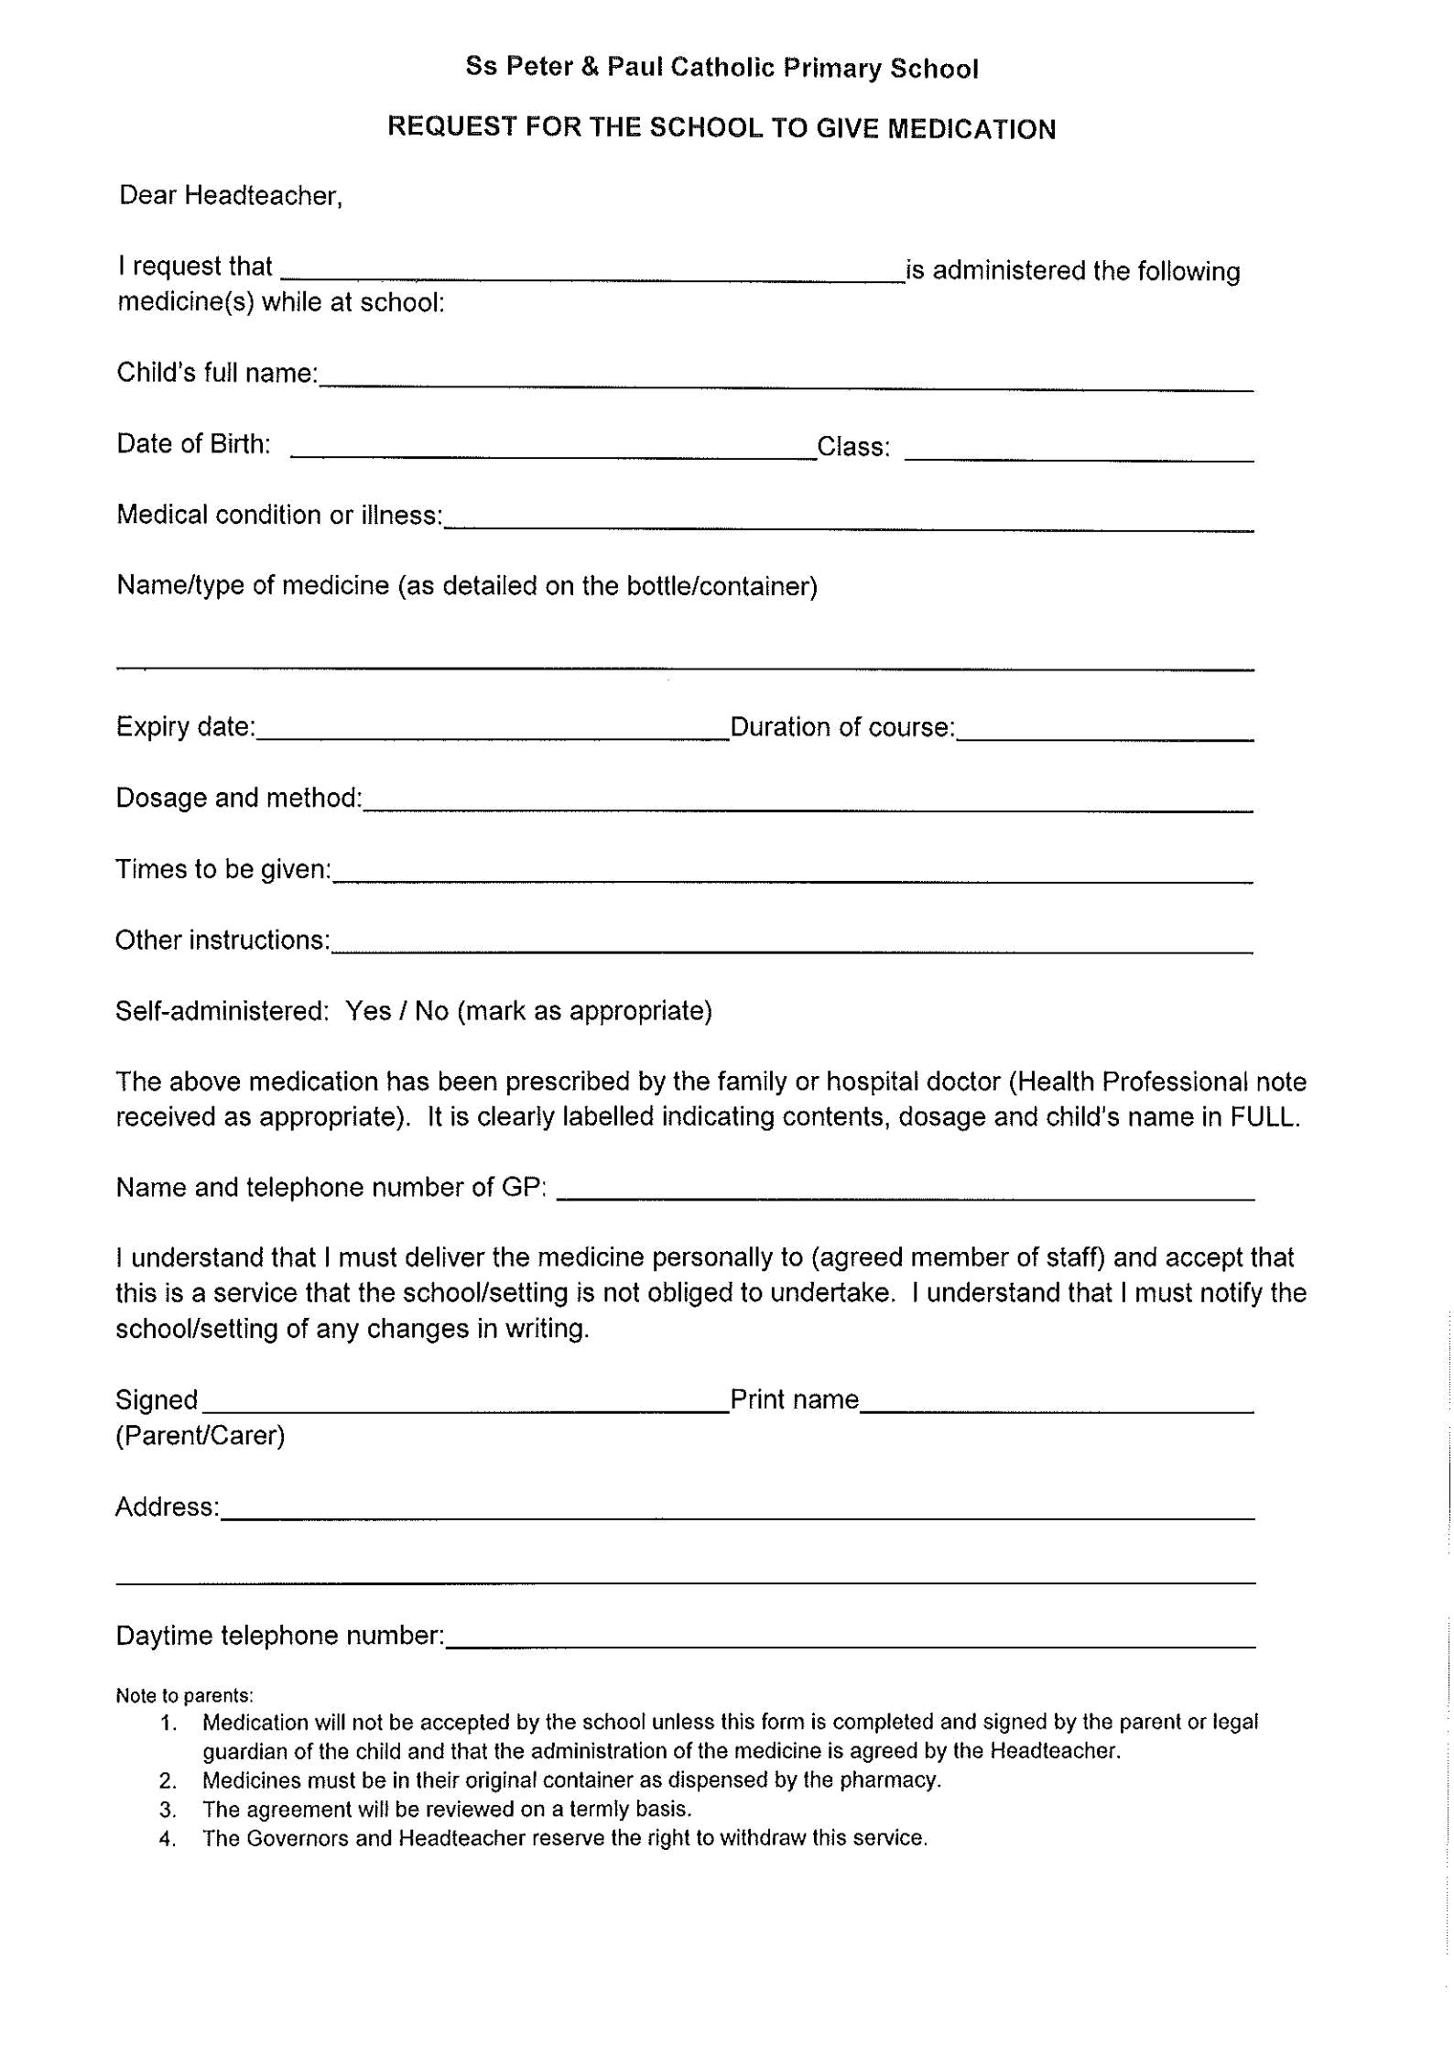

NB: Medicines must be in the original container as dispensed by the pharmacy
The above information is, to the best of my knowledge, accurate at the time of writing and I give consent to Ss. Peter and Paul Primary School staff administering medicine in accordance with the school’s policy. I will inform the school immediately, in writing, if there is any change in dosage or frequency of the medication or if the medicine is stopped.

Signature(s) ____________________ Date ______________________________

Appendix B Record of medicine administered to an individual child

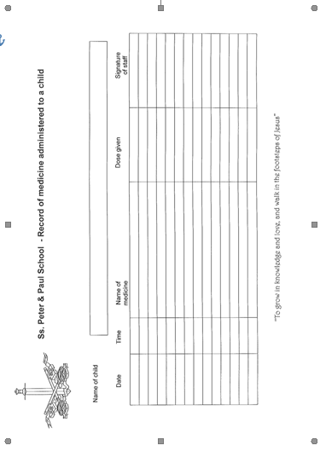

Appendix C Staff Training Record – Administration of Medicines

Name of school/setting | Ss. Peter and Paul Catholic Primary School
Name
Type of training received
Date of training completed
Training provided by
Profession and title

I confirm that __________________________________________ has received the training detailed above and is competent to carry out any necessary treatment. I recommend that the training is updated every year / every 2 / 3 years (delete as appropriate).

Trainer’s signature ________________________________

Date __________________

I confirm that I have received the training detailed above.

Staff signature ________________________________

Date __________________

Suggested review date __________________

7

